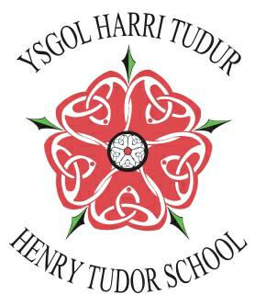
Ysgol Harri Tudur
Henry Tudor School

Extra-Curricular Opportunities Timetable
The list below is not exhaustive, more clubs and societies are being added on a regular basis…
Day / Session | Monday | Tuesday | Wednesday | Thursday | Friday
Pre-School | Gym Breakfast Club |  | Gym Breakfast Club
Break 1 | Dodgeball Yr 7 & 8  Open Library | Library: Book Club Yr 7&8 Astroturf Football Yr 9 | Open Library  Dodgeball Yr 7 & 8  Grace Group | Open Library  Astroturf Football Yr 8&10 | Open Library
Break 2 | Soul Band  Netball  Astroturf Football Yr 8  Open Library | Musical Futures  Astroturf Football Yr 7 & 10  Mixed Gymnastics Yr 7 – 9  Open Library | Astroturf Football Y 7  Girls Football Yr 7 – 11  Girls Gymnastics Yr 7 – 9  Library: Readers of the Round Table Yr 9+ | String Group  Debating Club  Library Doctor Who Club  Astroturf Football Yr 9  ALN Football Yr 7 – 9 | Open Library  Racquet Sports Yr 7 - 10
After School | IT Coding Club  Sixth Form Seren  Netball Yr 7, 8 & 9  Hockey Yr 10-13  Rugby Yr 7, 8 & 9  Handball Yr 7 & 8  Library Study Club | Orchestra  Netball Yr 10 – 13  Hockey Yr 7 – 9  Cross Fit (all Yrs)  Library Study Club  Rocket Club Yr 10& 11  Photography Club (all Yrs) Art Club (all Yrs) | Show Choir Rehearsals  Library Study Club  Science Club Yr 7 – 10 Multiple sporting fixtures  Girls Rollerblading Yr 7 – 9 | Library Study Club | Drama Club  Film / Cinema Club  Music Activities  Duke of Edinburgh  Library Choices Club (Creative Writing, Reading, Homework etc)  Multiple Sports & Exercise activities (changed regularly)
Further clubs in the following areas and subjects are being considered for the future:
Maths Challenge Club, CriwCymraeg, History Club & Languages Club. Check with Main Reception for activity venues if uncertain.

